**Wiggofy Press Release:**

Wiggofy yourself and help Bradley Wiggins win Sports Personality of the Year 2012!

This iPhone app ‘Wiggofy’ adds Bradley’s distinctive ginger sideburns and hair to your face and then allows the user to post to Facebook and Twitter as shown below:

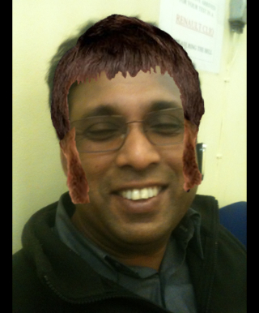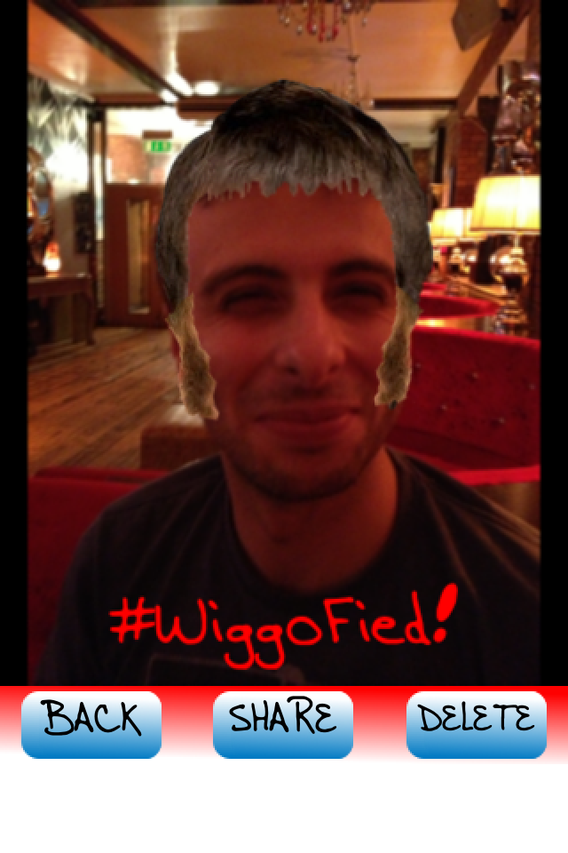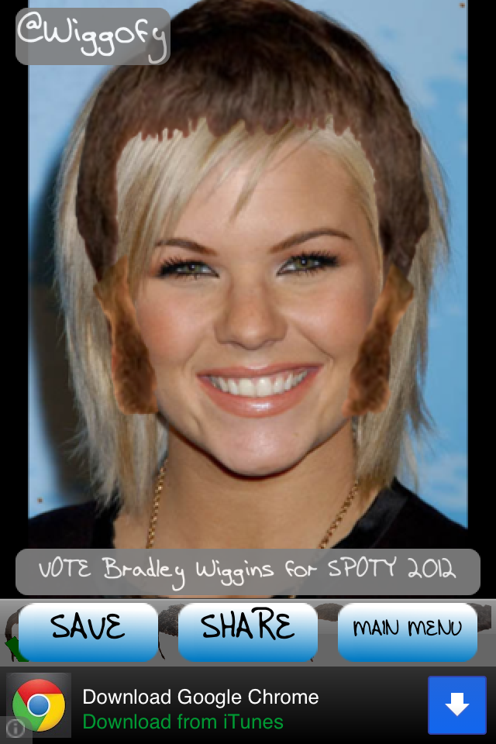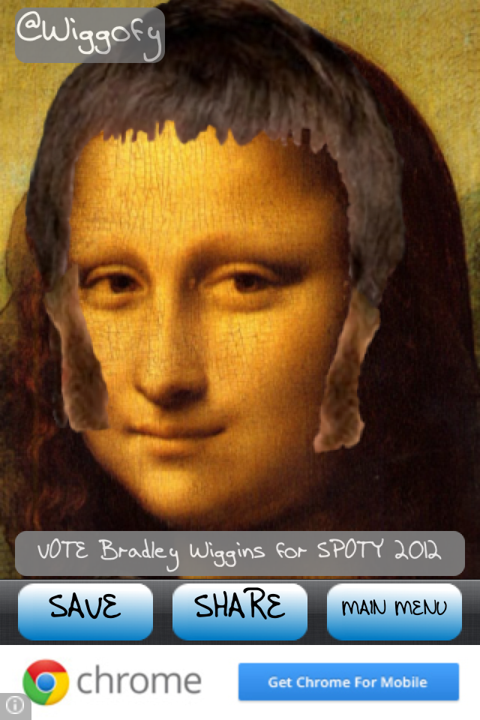

Wig-mania swept the country during the Olympics – everyone from TV presenters to Sir Steve Redgrave were sporting sideburns in honour of Bradley Wiggins. Celebrate his achievements and help raise awareness of the “Wiggofy” iPhone app and Facebook and Twitter campaign to get Bradley in his rightful place of Sports Personality of the Year 2012.

He is one of the most decorated medalists Britain has ever seen, winning Gold medals at three Olympic Games and the only British winner of the Tour De France. Bradley is a ‘tour de force’ and a style icon. Competition for Sports Personality of the Year 2012 is intense as there were so many stellar performances at the Olympics and elsewhere. Help Bradley win through this social media campaign.

<http://www.wiggofy.com>

<http://www.facebook.com/BradleyWigginsForSportsPersonality2012>

<http://twitter.com/wiggofy>

ENDS

Note to editors:

The ‘Wiggofy’ app is a harmless bit of fun, adding to the fever of Olympic year and the speculation over Sports Personality of the Year. It has been developed by Ben Smith who can be contacted on this number or email.

**Mobile: 07729529863**

**Email: benjaminsmith1981@googlemail.com**